World Conference on Transport Research - WCTR 2023 Montreal 17-21 July 2023

Pavement Performance Prediction using Machine Learning: Supervised Learning with Tree-Based Algorithms

[1]

Abstract

This article applies supervised machine learning tree-based algorithms to predict the performance of flexible pavements. The algorithms used were Decision Tree, Random Forest, and eXtreme Gradient Boosting (XGBoost). Likewise, the International Roughness Index (IRI) was adopted to represent the pavement's quality. Data to develop the machine learning models were collected from the Long-Term Pavement Performance InfoPave database. From this database, 55 experimental sections of asphalt concrete on granular base and asphalt concrete on bound base were selected. Also, only pavements without maintenance or rehabilitation were considered. For training the models, the features were the structural number, annual average daily truck traffic, precipitation, and temperature; IRI was the target. Finally, the best model developed was the XGBoost (R-squared of 0.98), followed by the Random Forest (R-squared of 0.95).

© 2023 The Authors. Published by Elsevier B.V.  
This is an open access article under the CC BY-NC-ND license (<https://creativecommons.org/licenses/by-nc-nd/4.0>)

Peer-review under responsibility of the scientific committee of the World Conference on Transport Research – WCTR 2023.

*Keywords:* Pavement; Performance; Machine Learning; Supervised Learning; Decision Tree; Random Forest; XGBoost; IRI.

Highlights

* Supervised learning tree-based algorithms show promising results for predicting the performance of flexible pavements.
* The models with the best results were XGBoost and Random Forest.
* The most important feature for predicting the IRI of flexible pavements is the annual average daily truck traffic.

# Nomenclature

AADTT Annual Average Daily Truck Traffic

AAT Annual Average Temperature

FHWA Federal Highway Administration

IRI International Roughness Index (IRI)

LTPP Long-Term Pavement Performance

ML Machine Learning

PMS Pavement Management System

RMSE Root-Mean-Square-Error

SN Structural Number

TAP Total Annual Precipitation

XGBoost eXtreme Gradient Boosting

1. Introduction

To maintain a road network in good service condition, a Pavement Management System (PMS) is essential. Likewise, one of its main components is the pavement performance model (Ferreira et al., 2009; Jorge and Ferreira, 2012). This study compares three supervised Machine Learning (ML) models applied to predict the performance of flexible pavements. Tree-based algorithms were employed. This choice was based on the capacity and interpretability demonstrated by these algorithms. Also, the pavement quality indicator was the International Roughness Index (IRI), a widely used pavement smoothness and irregularity monitoring parameter (Fwa, 2006).

The algorithms selected were Decision Tree (Quinlan, 1986), Random Forest (Breiman, 2001), and XGBoost (Chen and Guestrin, 2016). The model created aims to predict the IRI of flexible pavements until its first intervention. Therefore, only pavements without maintenance or rehabilitation were considered.

The workflow adopted is to study the problem, obtain data, prepare the data, apply the model, evaluate the results, improve the model, and conclusively put the model into production (O'Neil and Schutt, 2013; Géron, 2017; Thakur, 2020). The data used are from the Federal Highway Administration (FHWA) program called Long-Term Pavement Performance (LTPP) InfoPave (LTPP, 2020). As a result, data from monitoring sections of the asphalt concrete on granular base and asphalt concrete on bound base were analyzed. The data represents IRI, pavement structure, traffic, and climate conditions.

Among the contributions of our work, the evidence that supervised learning tree-based algorithms has good results for calculating the IRI stands out. In addition, the most important features to train the models and the best algorithms were found.

Finally, this article is structured into five sections. Section two presents the background. Section three provides information about tools, models, data, and methods. Section four discusses the results, and section five summarizes the main findings.

1. Background

A pavement performance model predicts a road network's quality based on monitoring data. According to Meegoda et al. (2014), truck traffic volume, climatic data, and the pavement's structural condition are recommended variables for pavement performance prediction models. As well, IRI is the main parameter used to define pavement smoothness (Fwa, 2006). The roughness of a road is defined by the variation in the surface that induces vibration in vehicles (Sayers et al., 1986). Likewise, Gillespie (1992) states that the IRI "is a scale for roughness based on the response of a generic motor vehicle to the roughness of the road surface". Therefore, the IRI is an index representing the vertical response of a hypothetical quarter-car traveling at 80 km/h and is calculated based on the vehicle's responses to variations in the pavement surface, generating an average longitudinal profile of the road (Fwa, 2006).

Since the end of the 1980s, the LTPP program has aimed to provide information that supports the development of models to explain the performance of road pavements (FHWA, 2019). The LTPP program has an online viewing platform called InfoPave (LTPP, 2020), where data from 2581 monitoring sections are available. This database supports several studies and is the most important database with road pavement data.

This study uses supervised machine learning models to predict IRI based on features such as traffic, pavement structure, and climate data. In supervised learning problems, multiple targets are associated with the dataset's existing data, so the model learns by example (Thakur, 2020).

The tree-based models are built on supervised learning, i.e., it is a mathematical structure that, given a target value Y, a prediction is made given an input X. Thus, to use these models, it is necessary to have a dataset with training values (features) and target values (labels) (Géron, 2017). In a tree-based model, the aim is to get a classifier to simulate the structure of a tree. The nodes correspond to the features, and the leaves to the classifications or predictions (Quinlan, 1986). Figure 1 shows a generic example of the Decision Tree structure. Lastly, decision trees are popular because they provide good results and are easy to implement and interpret (Gottard et al., 2020; Lundberg et al., 2020).

Figure 1. Generic tree example

1. Materials and Methods

The algorithms applied were Decision Tree (Quinlan, 1986), Random Forest (Breiman, 2001), and XGBoost (Chen and Guestrin, 2016). The workflow adopted to train the models followed the steps covered by Thakur (2020), Géron (2017), and O'Neil & Schutt (2013). Initially, it is necessary to understand the problem, from which the data was collected and then pre-processed, transformed, and prepared for the model. At that time, the data was split into training and testing datasets. The training dataset is utilized to train the model. Then, an independent test dataset is used to evaluate the performance. Depending on the metrics adopted, the model may advance to production, or it may be necessary to improve the algorithm. The workflow is shown in Figure 2.

Figure 2. Typical machine learning workflow

* 1. Experiment environment

The repository with all data, models, and instructions is available at: [github.com/tamagusko/predict-iri-trees](https://github.com/tamagusko/predict-iri-trees).

The Python version used was 3.9.15. The computer used to develop models have the following specifications:

* CPU: AMD Ryzen 9 5950X
* Memory: 32 GB DDR4 3000 MHz RAM
* GPU: NVIDIA GeForce RTX 3090 24 GB
* Operating System: Arch Linux, Kernel 6.0.8-arch1-1
  1. Data

The data to train the ML model were collected from InfoPave (LTPP, 2020). Monitoring sections classified as asphalt concrete on granular base and asphalt concrete on bound base were selected. The training features used data representing the pavement structure (Structural Number), performance (IRI), traffic (Annual Average Daily Truck Traffic), and climate indicators (Total Annual Precipitation and Annual Average Temperature). Only sections without maintenance and rehabilitation were selected. This choice was due to the complexity that different pavement interventions could add to the model. After the filters, 55 sections distributed across the US, Canada, and Puerto Rico became available (Figure 3). The distribution of monitoring sections is not uniform in the American territory. Most of them are located near the coast and on the east coast. This can generate biases in the models developed. However, the LTPP database is the most significant existing and has been the source of several studies. In the future, our team plans to use data augmentation and synthetic data to overcome this challenge. Table 1 describes the features selected to develop the machine learning models.

Figure 3. Sections of the LTPP program used in this study

Table 1. Descriptive statistics of features used to train the model

|  |  |  |  |  |  |  |
| --- | --- | --- | --- | --- | --- | --- |
| Feature | Mean | Min | 25% | 50% | 75% | Max |
| Year | 1996 | 1989 | 1992 | 1995 | 1999 | 2017 |
| IRI (m/km) | 1.34 | 0.61 | 0.92 | 1.20 | 1.60 | 4.10 |
| SN | 4.16 | 1.10 | 2.80 | 4.20 | 5.30 | 8.00 |
| AADTT | 452 | 4 | 142 | 262 | 526 | 3126 |
| Precipitation (mm) | 1010 | 92 | 715 | 1061 | 1334 | 2091 |
| Temperature (°C) | 13.80 | 2.70 | 7.90 | 15.30 | 17.50 | 25.90 |

The data under study are distributed between 1989 and 2017. Meanwhile, information is not available for each section in all monitoring years. Most of the data used are concentrated between 1992 and 1999. Also, the data are concentrated in sections with an IRI lower than 2.0 m/km. Consequently, the model is expected to have better results for lower IRI values.

The training features were Structural Number (SN), Annual Average Daily Truck Traffic (AADTT), Total Annual Precipitation (TAP), and Annual Average Temperature (AAT), while the target (value to be predicted) is the IRI.

The data used to develop the ML model is presented in Figure 4. The lower part of the triangle represents the scatter plot, and the upper part represents the correlation between variables. As expected, the highest correlation is related to the AADTT and the SN, i.e., the roads with higher traffic were designed with a more robust structure.

Figure 4. Matrix with processed data for model development

* 1. Data processing

The data were organized in a relational database (rows and columns). For each row, the information presented corresponds to a section and year. There is no correlation between different years for the same section. Consequently, each row corresponds to an individual input for the machine learning model, with features and a target. A snippet with the first five rows is shown in Table 2.

Table 2. Data processed for the study

|  |  |  |  |  |  |  |
| --- | --- | --- | --- | --- | --- | --- |
| ID | Year | Precipitation (mm) | Temperature (°C) | AADTT | SN | IRI (m/km) |
| 773 | 1989 | 434 | 15.1 | 520 | 4.7 | 0.90 |
| 1181 | 1989 | 1404 | 4.4 | 195 | 2.8 | 0.87 |
| 1182 | 1989 | 1404 | 4.4 | 195 | 2.8 | 0.85 |
| 1183 | 1989 | 1404 | 4.4 | 195 | 2.8 | 0.86 |
| 1106 | 1989 | 1178 | 5.1 | 586 | 2.8 | 1.76 |
| 773 | 1989 | 434 | 15.1 | 520 | 4.7 | 0.90 |

Furthermore, rows with missing values were excluded. Thus, from a total of 3,166 entries from the 55 monitoring sections, 2,203 remained with valid data for training and testing the model after processing. In this study, no investigation or cleaning of outliers was performed. Therefore, the results could differ depending on the process adopted to remove outliers.

Finally, a random split was performed with 75% of the data for training and 25% for testing. Accordingly, 1,652 sections were used for training and 551 for testing.

* 1. Parameter Optimizing

The optimization of the tree's depth was made (Figure 5). The objective is to find the optimal value for which a higher R-squared and the lowest Root-Mean-Square-Error (RMSE) are obtained. This activity was performed to minimize the possibility of overfitting and underfitting.

Figure 5. Tree depth tuning

The XGBoost algorithm converges with fewer interactions. Hence, the maximum depth of ten was adopted for the Decision Tree and Random Forest. For the XGBoost, the value four was used. Default values were adopted for the other training parameters.

1. Results

The execution time of these models on the workstation described in item 3.1 was only few seconds. However, this value is unimportant for a PMS, since the prediction of pavement quality is an activity that must be performed only few times a year. Thus, it can be said that the computational power required to process 55 monitoring sections is low. The first element evaluated is the importance of the features to the predictions (Table 3).

Table 3. Feature importance for models

|  |  |  |  |
| --- | --- | --- | --- |
| Feature | Decision Tree | Random Forest | XGBoost |
| AADTT | 34.4% | 34.0% | 32.3% |
| SN | 22.8% | 17.3% | 29.1% |
| Temperature | 17.0% | 18.9% | 15.8% |
| Precipitation | 11.9% | 17.4% | 11.8% |
| Year | 13.9% | 12.4% | 11.0% |

The importance of features had a similar order to the models developed. The most important feature was traffic (AADTT), corresponding to approximately one-third for all models. The second position was the pavement structure (SN) for the Decision Tree and XGBoost algorithms. However, in Random Forest, there was an inversion with temperature in second place. As the Random Forest algorithm gave less importance to structural capacity, greater weight was allocated to climatic factors, mainly precipitation. Thus, the XGBoost model, unlike the previous ones, took more into account the structural capacity. Based on Table 3, the Random Forest algorithm seems more robust because it better distributes the weights among the various features. Finally, the percentages show that the choice of features to train the models was adequate.

Predictive ability and errors were tested to choose the best model. In the error analysis, the indicators used were the R-squared and the RMSE. For R-squared, the goal is to get as close as possible to value one, i.e., predicted values would be the same as actual field measurements.

For RMSE, the goal is to have the slightest possible error. Figure 6 shows the results and a comparison between the result models. Predictive values are indicated on the vertical axis and measured on the horizontal axis. Thus, an ideal model would have its points on the diagonal that connects the axes. In the first model, the Decision Tree (green), it is seen that some measured values are outside the diagonal. The results were good for the Random Forest (blue), with an R-squared of 0.95 and RMSE of 0.12 for the test sample. The XGBoost (red) gave the best results, with an R-squared of 0.98 and an RMSE of 0.08 for the test sample. This model quickly converged to desirable values in parameter tuning.

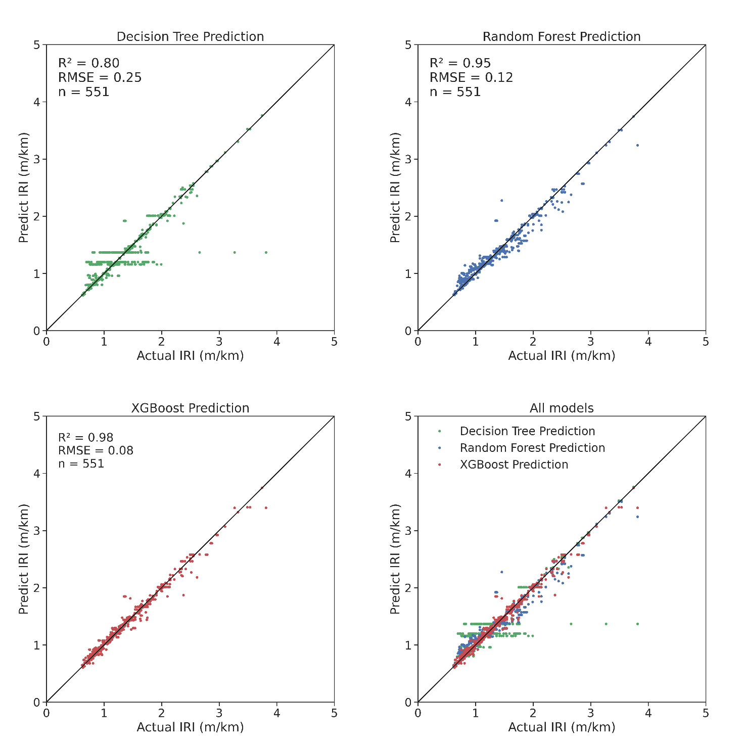

Figure 6. Results for the models evaluated on the test data

1. Conclusions

The results of the ML models were promising, especially for IRI values below 1.6 m/km. One possible explanation for this behavior is that these lower IRI values are in the early stages of pavement life cycle. Hence, pavement deterioration is usually almost linear, being predictable. This behavior was expected because many IRI values are less than 2.0 m/km in the training data.

As the model is at the moment, it can be used to predict the IRI with SN, AADTT, and climate information (precipitation and temperature) without interventions. Besides, the model can be adapted to other structural or traffic parameters. Nevertheless, the models must be retrained, and the model's performance may be different. Even so, these developed models are good candidates to be the basis for transfer learning. Thus, agencies with fewer data can benefit from these models to apply in their local context. The models require little computational power for processing. The most time-consuming process was parameter optimizing, where the models were trained several times until they found the best values. Therefore, there are no problems applying this ML model by any agency with input parameters that want to predict the IRI's evolution.

Finally, the best model developed is the XGBoost, obtaining an R-squared of 0.98 and RMSE of 0.08, closely followed by Random Forest, with an R-squared of 0.95 and RMSE of 0.12. In the future, this model will be expanded to consider pavement interventions. Furthermore, models for 5, 10, and 20 years will be developed. It is also intended to create an auxiliary module able to test the IRI result according to planned interventions. Another objective will be to test the robustness of the model for data from sources other than LTPP. Data and models are available at [github.com/tamagusko/predict-iri-trees.](https://github.com/tamagusko/predict-iri-trees)

Acknowledgments

The first author would like to thank the support by the Portuguese Foundation for Science and Technology (FCT), which awarded the PhD scholarship grant 2020.09565.BD. The authors also would like to thank the support of the Research Centre for Territory, Transports and Environment (CITTA) and also ACIV for the presentation of this paper in the World Conference on Transport Research.

References

Breiman, L., 2001. Random forests 28. https://doi.org/http://dx.doi.org/10.1023/A:1010933404324

Chen, T., Guestrin, C., 2016. XGBoost: A Scalable Tree Boosting System. Proc. 22nd ACM SIGKDD Int. Conf. Knowl. Discov. Data Min. 785–794. https://doi.org/10.1145/2939672.2939785

Ferreira, A., Picado-Santos, L., Antunes, A., 2009. Pavement Performance Modelling: State of the Art. Comput. Tech. Civ. Struct. Eng. 58, 157–164. https://doi.org/10.4203/ccp.58.8.1

FHWA, 2019. Long-Term Pavement Performance Information Management System User Guide 2019 [WWW Document]. URL https://infopave.fhwa.dot.gov/ (accessed 9.25.20).

Fwa, T., 2006. The handbook of highway engineering.

Géron, A., 2017. Hands-On Machine Learing With Scikit-Learn & Tensor Flow, Hands-on Machine Learning with Scikit-Learn and TensorFlow. O'Reilly Media. https://doi.org/10.3389/fninf.2014.00014

Gillespie, T.D., 1992. Everything You Always Wanted to Know about the IRI, But Were Afraid to Ask! https://doi.org/10.1109/msp.2006.65

Gottard, A., Vannucci, G., Marchetti, G.M., 2020. A note on the interpretation of tree-based regression models. Biometrical J. 62, 1564–1573. https://doi.org/10.1002/bimj.201900195

Jorge, D., Ferreira, A., 2012. Road network pavement maintenance optimisation using the HDM-4 pavement performance prediction models. Int. J. Pavement Eng. 13, 39–51. https://doi.org/10.1080/10298436.2011.563851

LTPP, 2020. Long-Term Pavement Performance program's data portal [WWW Document]. URL https://infopave.fhwa.dot.gov (accessed 9.25.20).

Lundberg, S.M., Erion, G., Chen, H., DeGrave, A., Prutkin, J.M., Nair, B., Katz, R., Himmelfarb, J., Bansal, N., Lee, S.-I., 2020. From local explanations to global understanding with explainable AI for trees. Nat. Mach. Intell. 2, 56–67. https://doi.org/10.1038/s42256-019-0138-9

Meegoda, J.N., Gao, S., 2014. Roughness progression model for asphalt pavements using long-term pavement performance data. J. Transp. Eng. 140, 1–7. https://doi.org/10.1061/(ASCE)TE.1943-5436.0000682

O'Neil, C., Schutt, R., 2013. Doing Data Science: Straight Talk from the Frontline. O'Reilly Media.

Quinlan, J.R., 1986. Induction of decision trees. Mach. Learn. 1, 81–106. https://doi.org/10.1007/bf00116251

Sayers, M.W., Gillespie, T.D., Queiroz, C.A.V., 1986. The International Road Roughness Experiment (IRRE): establishing correlation and a calibration standard for measurements.

Thakur, A., 2020. Approaching (Almost) Any Machine Learning Problem.

1. * Corresponding author. Tel.: +351-239-797-101.

   *E-mail address:* adelino@dec.uc.pt